**Website Clubs from the Sports Fair 2011**

**Example 1:**

“Caterham and Whyteleafe Tennis Club – Manor Park Whyteleafge (access off lower end of Burntwood Lane.) Rates of subscription (2011) ₤84 single, ₤120 family and ₤22 junior. Newcomers and beginners are welcome. See website [www.cw-tennis.org.uk](http://www.cw-tennis.org.uk/). Phone 01883 625463.”

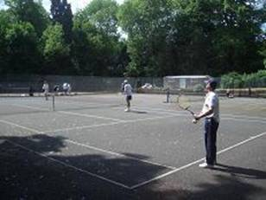

**Example 2:**

Pleiades Netball Club - see attachment

Example 3:

Croydon Harriers Athletics Club: Head Coach – Mike Fleet

Please see Croydon Harriers Athletics Club website and Mike Fleet’s contact telephone for enquiries is 020 8647 1341. We pride ourselves in being a family club.

We are based at:   
  
Croydon Sports Arena   
Albert Road   
South Norwood   
London   
SE25 4QL   
  
Bus routes: 197 & 312   
Tram Routes: 1 & 2 ('Arena' stop)   
  
Croydon Arena enquiries: 020 8654 3462   
Croydon Harriers general enquiries: 0208 647 1341

Example 4: Mike Yorke Golf Academy – still waiting for information

Example 5: Aquasports

COME JOIN IN ON THE FUN, AND GET QUALIFIED WITH AQUA SPORTS!  
  
Kick start your adrenaline by getting into one, or all three, of the watersports that we offer in Windsurfing, Dinghy Sailing and Paddlesports, all in a highly safe, fun and controlled environment of our lake at Mercers Park.  
  
Activities for schools/ Outdoor Education:  We believe that outdoor education is a vital skill for students and here at Aqua Sports we are committed to the future development of Watersports for young people and to that end we offer two hour weekly PE lessons through to week-long multi-activity courses.  We deliver our courses to the exacting standards of the **Royal Yachting Association** (RYA) and the **British Canoe Union** (BCU) so regular visits can result in a qualification(s) for students.  
  
So if you want to just sail for fun with your friends and enjoy being out on the water, want to get fit, get qualified in an RYA or BCU watersport our highly qualified and motivated instructors can provided that experience.  
  
Web: [www.aquasports.co.uk](http://www.aquasports.co.uk)   Contact: 01734 644 288