GCSE Homework
Scenario
You have just won the lottery!!!! Good job, well done. It’s not enough to live your life without working, so you decide to open a Leisure Centre to make you money for the rest of your life and leave a legacy behind. Unfortunately it’s in a competitive area with other leisure centres vying for your customers.
Task
You need to create a leaflet detailing all the REASONS and BENEFITS of joining your leisure centre to get the paying customers through the door to ensure you are getting paid the big bucks.
You should include the main benefits:
Increase fitness, feel good, relieve stress and increase self esteem/confidence, improve health, enjoyment, mental challenge
and the main reasons:
Cooperation, competition, physical challenge, aesthetic appreciation, friendship and social mixing
Make sure you cover all the points and relate it to your ‘target audience’ so they know the REASONS and BENEFITS for joining your leisure centre over the competitors.
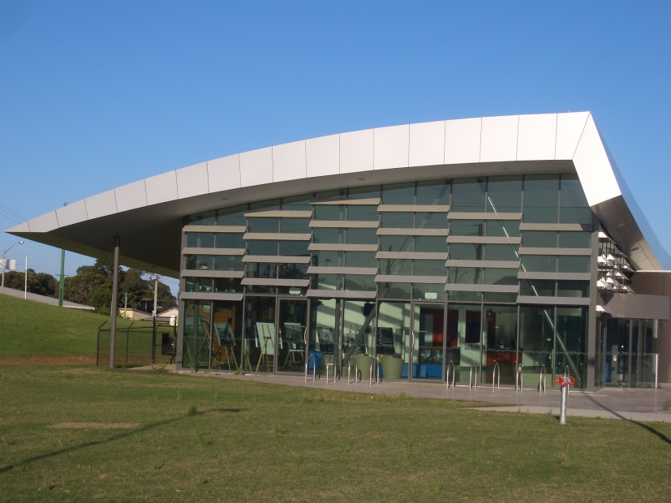

Due Date:

