Football / Short-Haul
Villarreal Club de Futbol
Easter 2016 / 5 Days – 4 Nights

Warlingham School
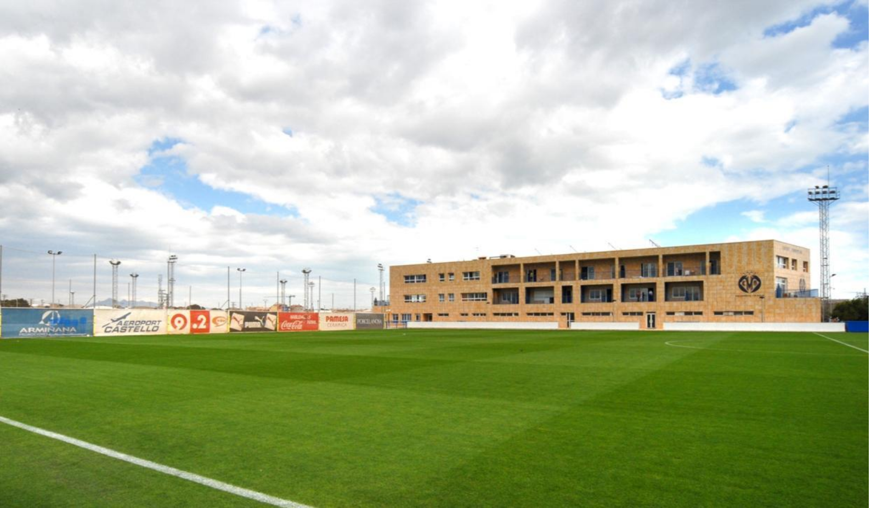

Selected Accommodation: 4* Intur Orange

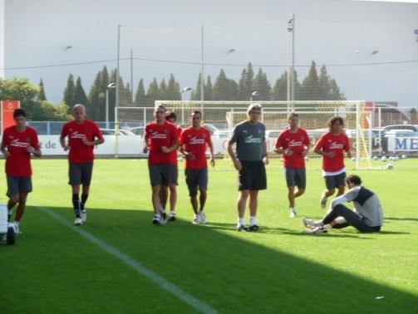
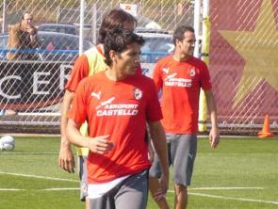

Background on the Club

Villarreal Club de Fútbol, S.A.D. (Valencian: Vila-real Club de Futbol, S.A.D.), usually abbreviated to Villarreal CF or just Villarreal, is a Spanish football club based in Vila-real, a city in the province of Castellón within the Valencian Community. Founded in 1923, they play in the first division Liga BBVA, commonly called LaLiga, holding home games at El Madrigal, with a capacity for 24,890 spectators. The club is nicknamed El Submarino Amarillo (Yellow Submarine) due to its yellow home kit, and due to being a low-profile team compared to Real Madrid, FC Barcelona, and Valencia CF, whom they have challenged for trophies over the last decade. Villarreal has often been touted as an example of small yet friendly open and successful club.

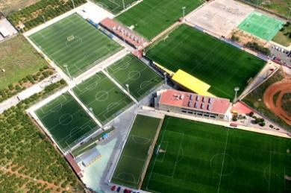
Training Facilities

All Villarreal CF teams from 7 years old to the first team train at Camino Miralcamp complex. The complex is also home to the main club office administration as well as the living quarters for the clubs top academy players. The facilities include three 7-a-side pitches, two 3rd generation artificial fields and two 11-a-side grass field, and a mini-stadium for the reserve team and U18 academy matches. The training complex is always open to the public and with the relaxed social atmosphere players seem to join in with the friendliness of the club and are happy to take time out for the fans

Your Tailor-Made Package Includes

• Pre-departure information service
• Return UK coach to airport
• Return flights to Spain (including all airport, airline and government taxes)
• Baggage allowance of 15kg or 20kg depending on airline (hold luggage only)
• Airport transfers in Spain
• Transfers to and from training
• 4 nights in 4* hotel accommodation (based on 2-4 sharing)
• Full board to include dinner on day one and lunch on final day (buffet style eat as much as you want breakfast & dinner)
• 4 training sessions on all aspects of play from the Villarreal CF full-time coaching staff
• Use of the first team and satellite training facilities for all scheduled training sessions with club coaching staff
• 1 pre-arranged match per team against similar standard local opposition (additional matches may be subject to a small supplement)
• Provision of an inspiresport branded underarmour football kit (shirt & shorts)
• Behind the scenes El Madrigal Stadium tour including visit to official club shop
• Presentation of player medals
• Afternoon at the local beach (100m from the hotel)
• Water provided for all training sessions
• Coach education opportunities for Sports Trip Organisers
• Services of a bi-lingual inspiresport representative to stay with you throughout the tour
• Final printed itineraries

Villarreal Package

Optional Extras (subject to availability)

• Lunch on day of arrival (if applicable)

• Tickets and transport to a professional fixture
• Bowling in Castellon

• Visit to water park (May-Sept only)

• Excursion to City of Arts and Science

• Extended stay

• Single room supplements

• Additional charges for rooms

• Additional matches
What is Not Included

• Personal expenditure

• Refundable deposits requested on arrival by some accommodation providers
• Cost of passport and visas

• Additional paying adults and single room supplements

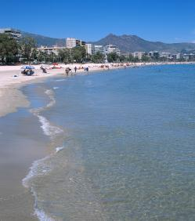

Villarreal Package

Tour Coordinator
inspiresport will have a team of staff at the course venue assisting with the administration and organisation of the trip. When you arrive at your destination our representative will meet you and will remain with you for the entire duration of tour trip. All our representatives are fully trained to ensure the trip is as enjoyable and as stress free as possible.

Assured Member of the School Travel Forum
inspiresport is an Assured Member of the School Travel Forum (STF) and in booking with us you can be secure in the knowledge that we:

• Understand and facilitate the needs of educational travel
• Have effective Safety Management Systems in place, specifically focused on travelling with young students
• Offer fair terms and condition and the best financial security

To ensure our health and safety standards are maintained our systems and procedures are fully audited annually by independent experts.

STF membership is the benchmark for good school tour providers; consequently it is an Awarding
Body for the prestigious Learning Outside the Classroom Quality Badge.

The Outdoor Education Advisors Panel (OEAP) endorses the Quality Badge and requests Local Authorities to recommend the use of Badged Providers and require the minimum of additional paperwork where Quality Badge accreditation is in place.

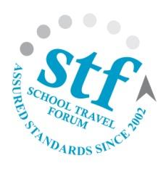
This means that you can book your trip with confidence, meet your due diligence and reduce the amount of External Provider paperwork necessary.

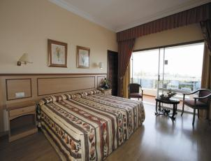
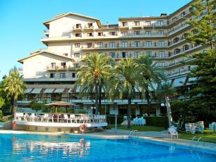

Accommodation

3* & 4* Hotel Intur Group
The Intur Hotel Group has three hotels (2 x 4* and 1 x 3*) located next door to each other in the beautiful coastal town of Benicassim, 150 metres from a white sandy beach. The hotel rooms are all en-suite rooms each have full internet access, air conditioning, and TV with satellite channels. Among other services that will make your stay unforgettable, the hotels offers a restaurant, a bar,
3 swimming pools, entertainment and a wide selection of sports facilities including paddle courts, table tennis, table football, mini-golf, technogym (over 16 year olds only), bicycle hire and a grass football pitch.

Distance to training complex – 12 miles Distance to beach front – 150 metres Distance to bowling complex – 7 miles
Distance to nearest airports – Valencia (40 miles), Alicante (150 miles), Reus (150 miles)

Financial Security

For your financial protection flight packages are protected by ATOL 6053 offering 100% security in the unlikely event of insolvency. All other packages by coach/ferry are financially protected by an ABTA bond. Insurance premiums are not protected.

Passport, Visa and Health Information

Updated passport, visa and health information can be obtained by visiting www.gov.uk/foreign- travel-advice. For travel to the USA visit www.esta.co.uk. For information on health requirements for your tour you should visit www.gov.uk/foreign-travel-advice.

